When clicking the ‘Training’ button at the bottom bar:

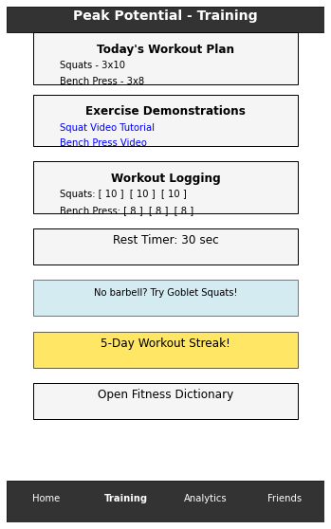

Opening the Fitness Dictionary:

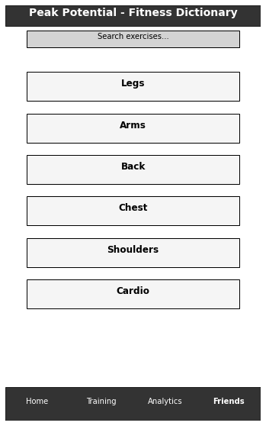

Selectin a body part that the user would want to work on:

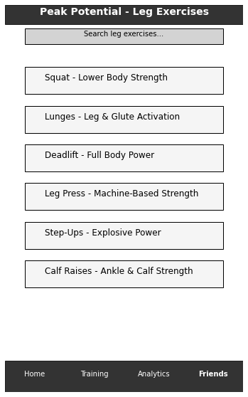

When clicking in one of the movements displayed in the dictionary,

